Behat Installation

Step 1 Installation of Ubuntu VM in Windows 7.

Why Ubuntu ->
- Ubuntu is a complete desktop Linux operating system, freely available with both community and professional support.
- Pre-installed tools like cURL(A command line tool for getting or sending files using URL syntax)

Download Oracle VM

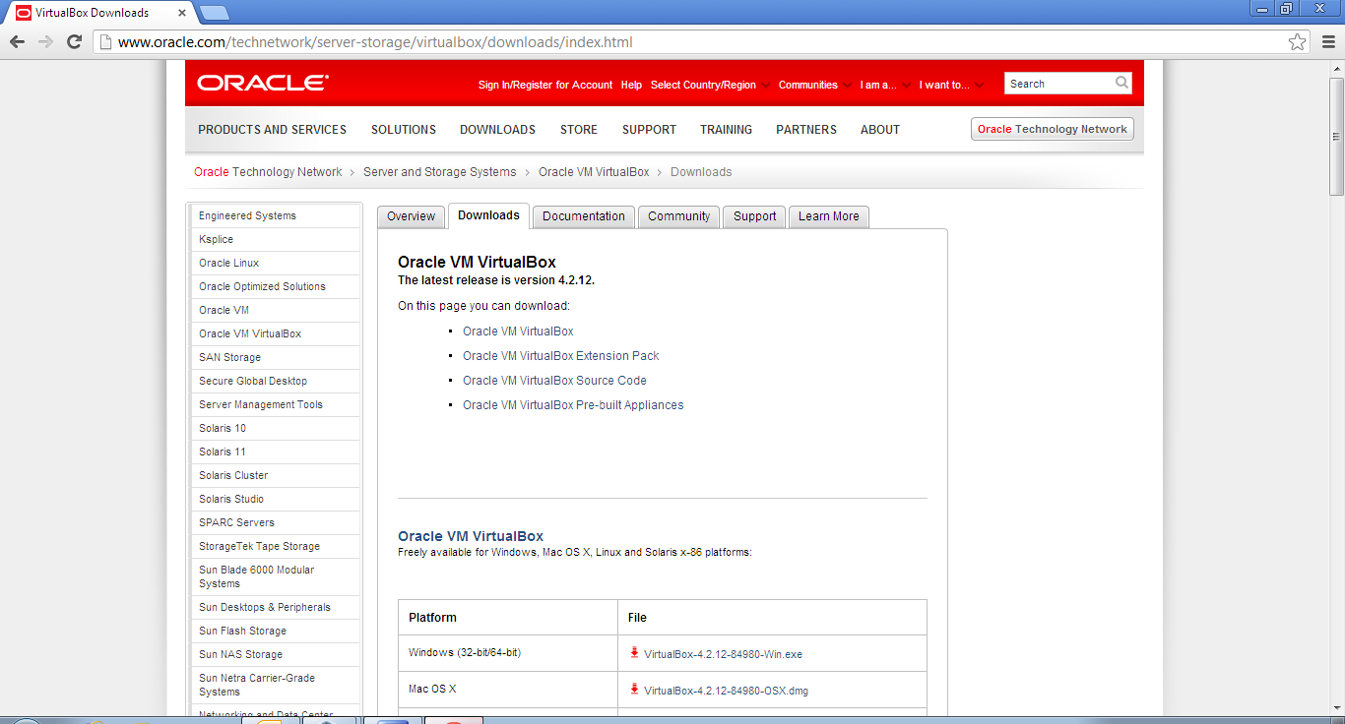

You need admin rights to install Oracle VM manager using exe just downloaded.

Download Drupal Quick Start .ova file.

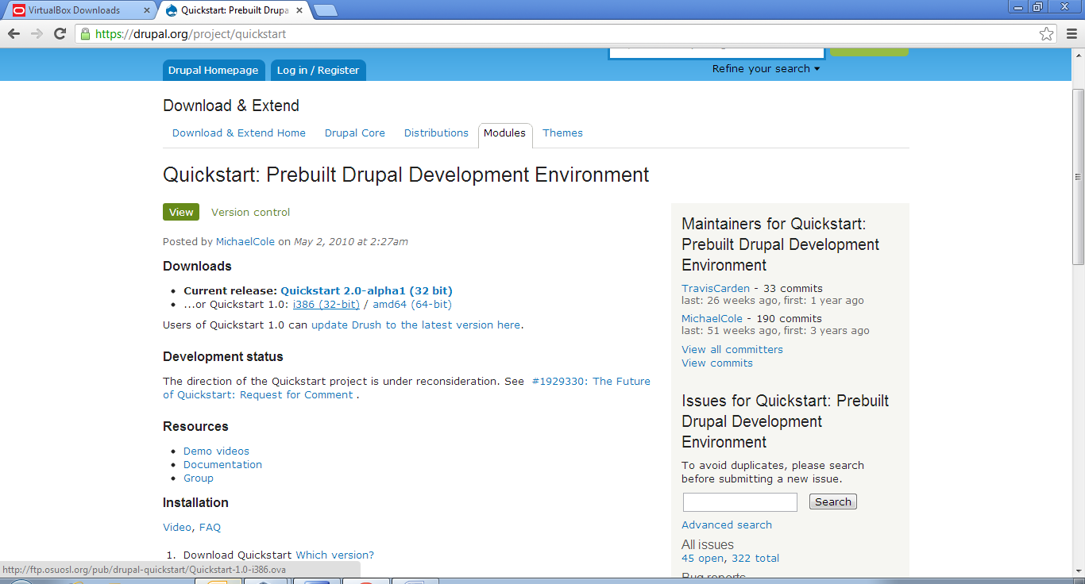

Now in Oracle VM click on File tab and select Import Application

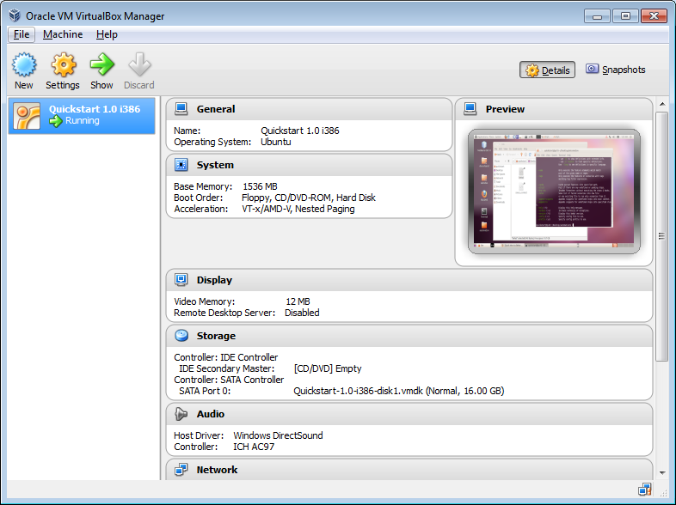
- Now import Appliance

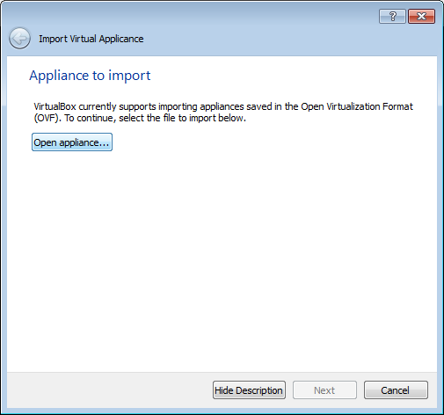

Select the ova file

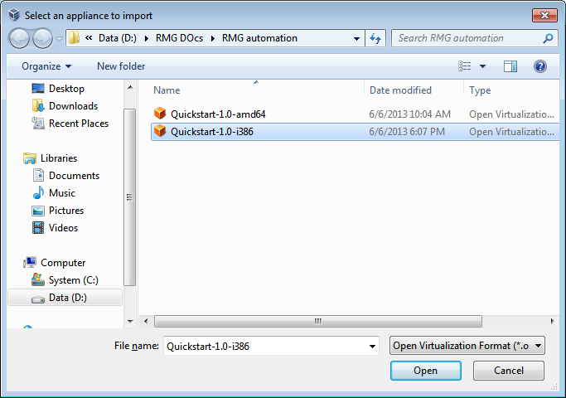

Step 2 Installtion of Behat on Ubuntu

Create a working directory
The simplest way to install Behat is through Composer. Before we begin, let’s install a few libraries. Start by creating a new directory and adding a composer.json file.
Composer is a tool that helps download external libraries into your project. We’ll be downloading Behat, Mink, and a few other related libraries into our working directory/folder.
Composer's main job is to download third-party libraries into a vendor directory in your project.
To tell Composer which libraries you need, your project needs to have a composer.json configuration file
More about composer on http://getcomposer.org/doc/00-intro.md
More about why to use composer https://knpuniversity.com/screencast/composer
Add below contents to your composer.json.
{
"require": {
"behat/mink": "1.4@stable",
"behat/mink-goutte-driver": "*",
"behat/mink-selenium2-driver": "*",
"behat/behat": "2.4@stable",
"behat/mink-extension": "*"
},
"minimum-stability": "dev",
"config": {
"bin-dir": "bin/"
}
}
The first is to download the Composer executable. Go to GetComposer.org, click "Download", and then copy one of the two code blocks depending if you have curl installed
curl http://getcomposer.org/installer | php
Composer itself is just an executable file, and this fancy bit of code downloads the file and makes sure your system is setup to use Composer.
We've downloaded the Composer executable and created the composer.json config file. To actually put Composer to work, run php composer.phar install. This is the most important command: it reads the composer.json file and downloads all the needed libraries into the vendor directory.
php composer.phar install --prefer-dist
And look, a vendor directory! It holds the all listed libraries and a few other things that help with autoloading - which is one of the most powerful features of Composer. When we ran the install command earlier, one of the things it did was create a composer.lock file that recorded the exact versions of all libraries that it downloaded at that exact moment.
Each library mentioned as in json file will be downloaded after a big wait and placed it into a new vendor/ directory inside working project directory. When it’s finished, you’ll also notice a new bin/ directory with a behat file in it. This is the Behat executable, and you’ll use it to run your tests and get debug information.

